# Header Setup

To set up the header for the Newsroom portfolio website, we will use the out-of-the-box (OOTB) header component in AEM.

**Steps:**

* 1. **Use the OOTB Header Component**:
     + Open the AEM Sites console and navigate to the page template or the Home page.
     + Use the **Header** component available in AEM to add the header to the template.

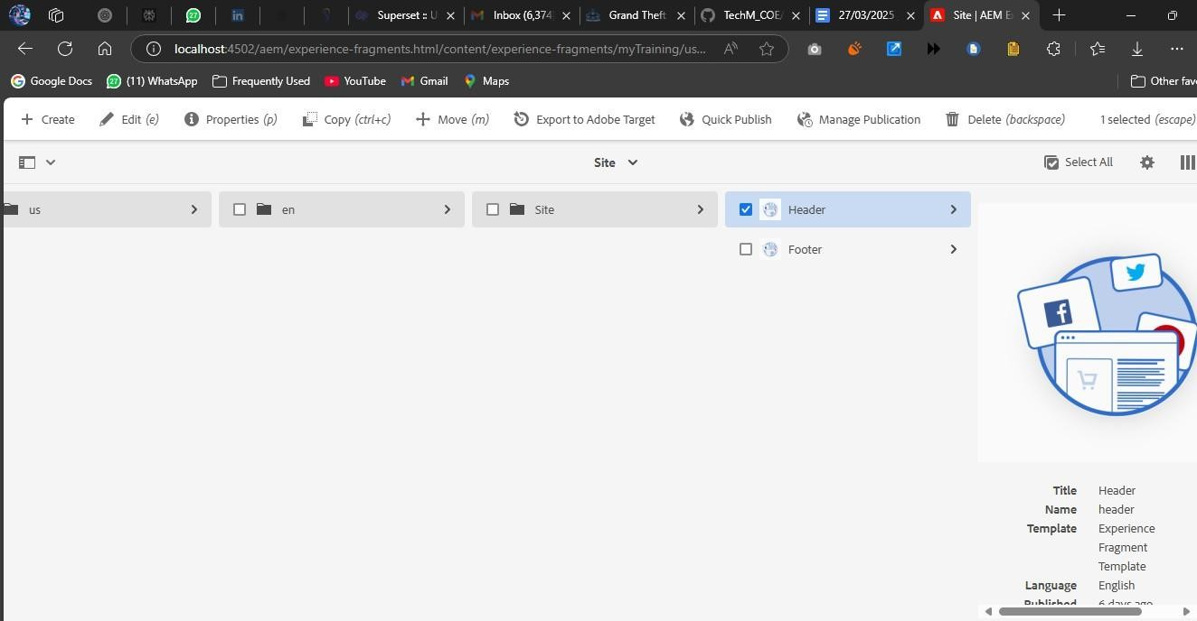

* 1. **Create Navigation Links**:
     + The navigation links in the header should include:
       - News (with a dropdown containing 5 news items)
       - About Me
       - Contact Me
       - Homepage

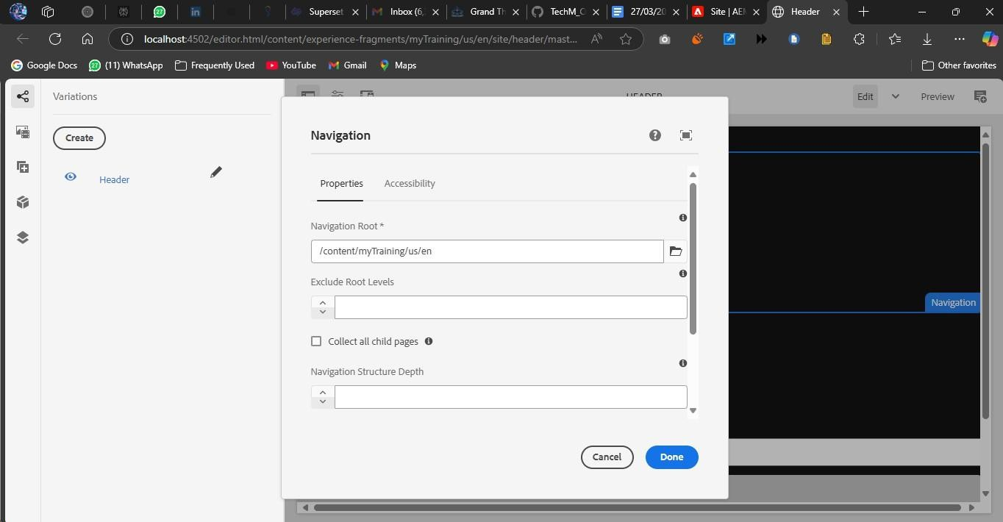

* 1. **Configure Drop-Down for News**:
     + For the **News** link, configure a drop-down that will display the latest 5 news articles. This can be done by adding a **teaser** component or **list component** to show news articles from the /content/news folder.

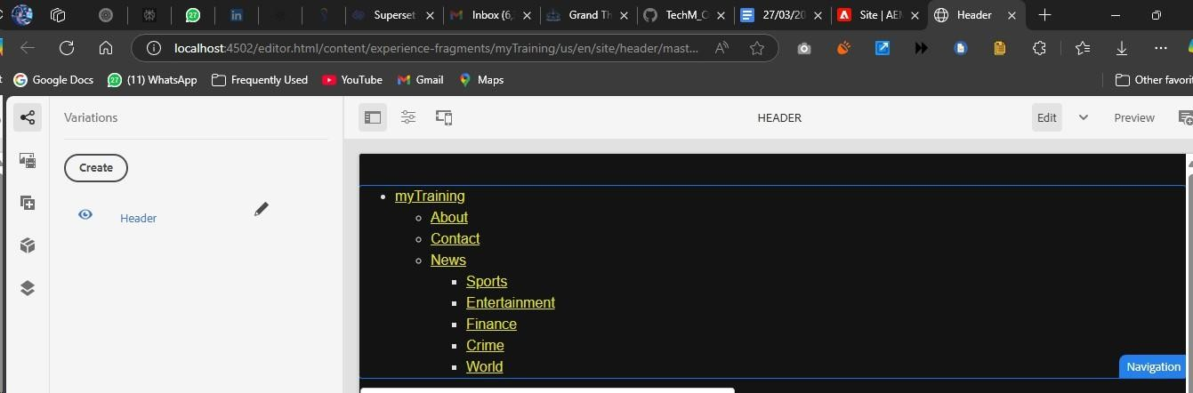

* 1. **Styling the Header**:
     + Use AEM’s **Style System** or **CSS** to ensure that the header has proper styling, such as alignment, spacing, and colors.
  2. **Ensure Navigation Links Work**:
     + Verify that the links are functioning and correctly navigate to their respective pages.

**HEADER VIEW:**

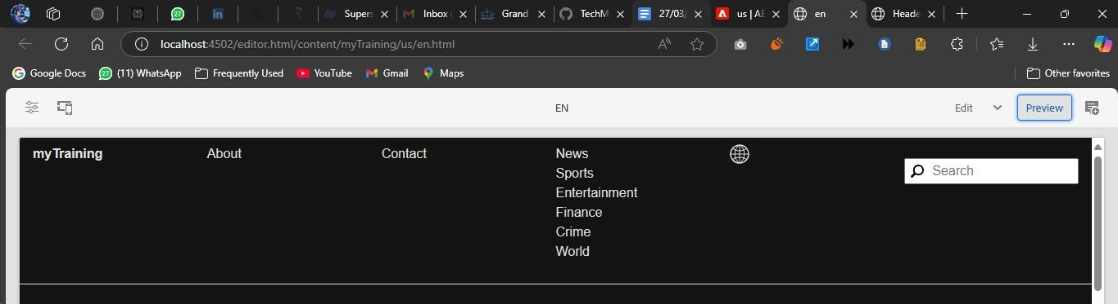

# Footer Setup

The footer should contain key links and information about the website, such as the About Me, Contact Me, and Latest News.

**Steps:**

* 1. **Add Footer to Template**:
     + Use the Footer component in AEM or create a custom footer by using text or links components to display information at the bottom of every page.

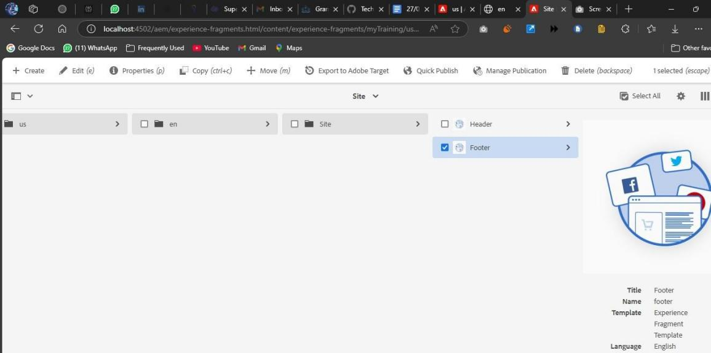

* 1. **Footer Sections**:
     + **About Me**: Link to the About Me page.
     + **Contact Me**: Link to the Contact Me page.
     + **Latest 5 News**: Display the latest 5 news articles with links. These should open in a new tab when clicked.
  2. **Social Media Section**:
     + Add social media links (Facebook, Twitter, Instagram, LinkedIn, etc.) using link components.

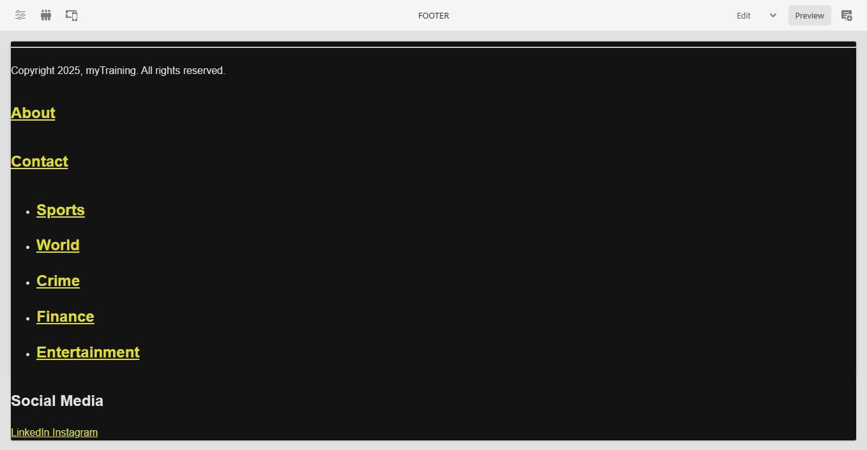

# Home Page

The home page will highlight a specific award ceremony for journalists using a teaser component.

**Steps:**

* 1. **Teaser Component for Award Ceremony**:
     + Use the **Teaser** component to display an award ceremony for journalists.
     + The teaser should have:
       - **Image**: Display an image of the award ceremony.
       - **Title**: Title of the award.
       - **Description**: A brief description of the award.
       - **CTA (Call to Action)**: Link to a page with more details about the award. Create a new page to author the full news article and link it to the CTA.
  2. **Style and Layout**:
     + Use AEM’s style system or custom CSS to ensure the layout and design match the desired outcome for the homepage.

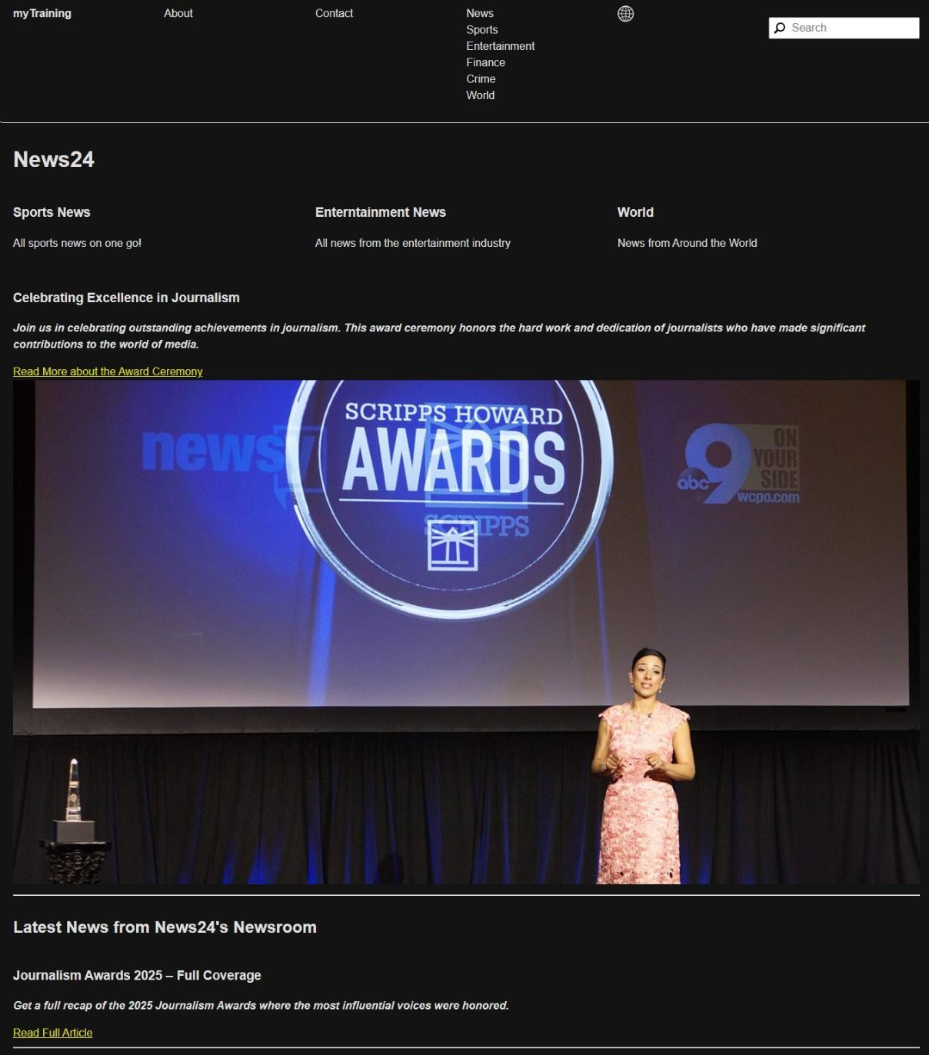

# News Page

For the News page, we need to create a **NewsRoom** component that will dynamically fetch and display news articles.

**Steps:**

* 1. **Create NewsRoom Component**:
     + The **NewsRoom** component should fetch all the news articles from the

/content/news folder.

* + - The component should display the articles as cards, each with:
      * **Title**
      * **News Detail**
      * **Image**

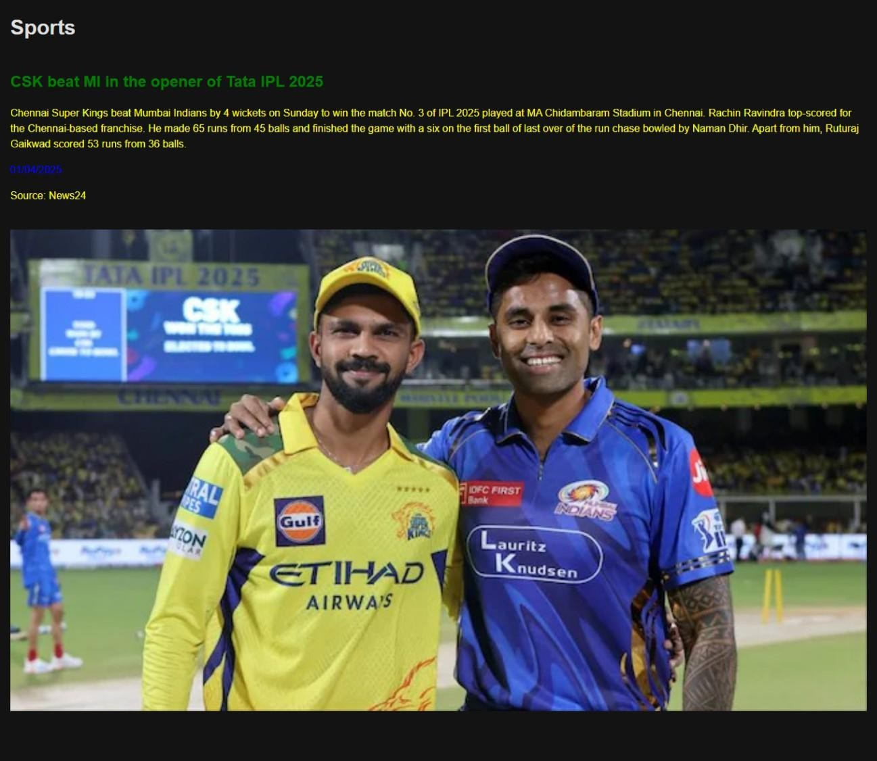

# About Me Page

The About Me page will display information about the journalist using a custom **Journalist Component**.

**Steps:**

* 1. **Use Journalist Component**:
     + Use the **Journalist** component to display information about the journalist. This component should show:
       - **Name**
       - **Bio**
       - **Image**
  2. **Design Layout**:
     + The layout should be simple and clean, displaying relevant information about the journalist.

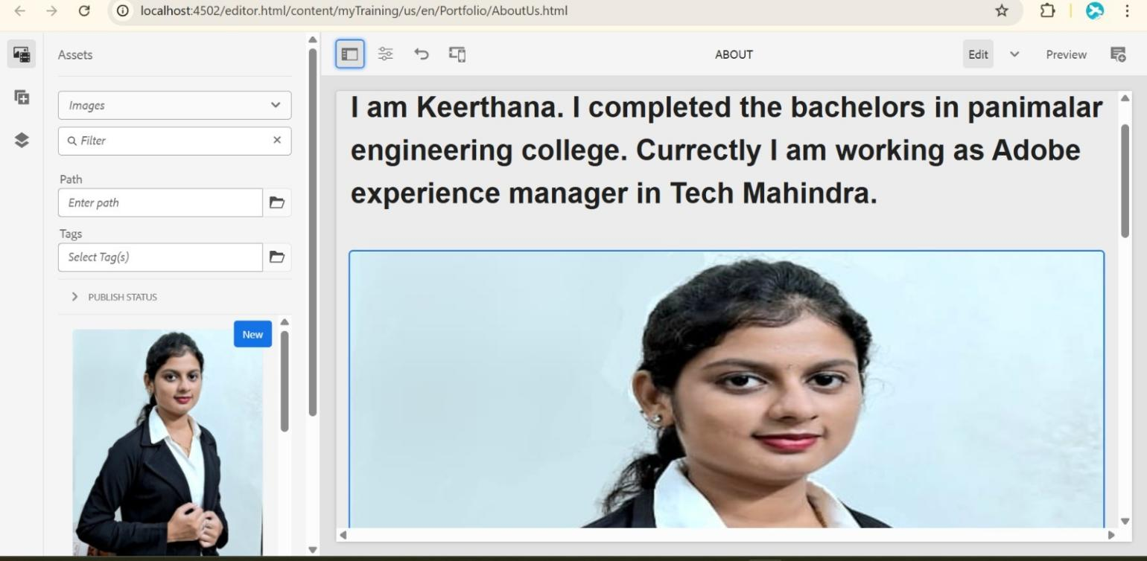

# Contact Me Page

The Contact Me page will allow users to reach out to the journalist. This can include basic contact details and social media profiles.

**Steps:**

* 1. **Add Contact Information**:
     + Use the **Teaser** or **Text** component to add the contact details.
  2. **Social Media Links**:
     + Include social media links (such as Twitter, LinkedIn, etc.) where users can follow the journalist.

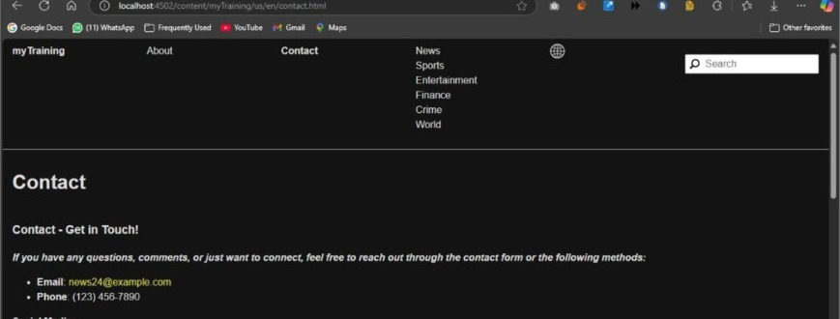

# Template Setup

Both the header and footer should be part of the template so that they can be reused on multiple pages.

**Steps:**

* 1. **Create a Template**:
     + Use the OOTB **Content Page Template** for the homepage.
     + Ensure the header and footer are placed at the template level so they appear on all pages.
  2. **Set Template for Pages**:
     + When creating pages, make sure they are using this template to automatically include the header and footer sections.

**CREATED THE NEWSROOM TEMPLATE: USES HEADER AND FOOTER BY DEFAULT:**

